**Govt. College of Arts, Science & Commerce,**

**SANQUELIM-Goa**

**Computer Science Journal**

**Certificate**

**This is to certify that the record work done by Mast. Suryakant Vithoba Paryekar of TYBSC class, bearing Roll no.21S0761 and of academic year 2023-24 and contained in this journal has been periodically examined and signed and the course of experimental work in COMPUTER SCIENCE PAPER- 3 “HCI”, during prescribed by the Goa University has been satisfactory carried out.**

|  |  |  |
| --- | --- | --- |
| Sr. No | TITLE | Pg. No |
| 1 | GOAL ACTION MODEL | 01 |
| 2 | CONDUCTING SURVEY INTERVIEW AND SUMMARISING THE RESULT | 02 |
| 3 | HEURISTIC EVALUATION | 04 |
| 4 | DESIGN PRINCIPLES | 05 |
| 5 | WEB USER INTERFACE DESIGN-PAGES, NAVIGATION | 07 |
| 6 | PAPER PROTOTYPING USING TEMPLATES | 17 |
| 7 | STORYBOARDING | 18 |
| 8 | PERSONA | 19 |

**Practical No: 1) GOAL ACTION MODEL**

**Goal**: use of visual studio code.

**Intention**: use visual studio code to run a python code.

**Specify**: 1) Click on the visual studio code icon to open the ide.

2) Create a new python file with ".py" file extension.

3) Write content to the file.

4) Save the file by clicking save button or press "ctrl+s".

**Execution**: click on the run icon to run the python code you have written.

**Perceiving**: see the output shown in the terminal.

**Interpreting**: if there are any errors in the code, make changes to the code.

**Evaluation**: the execution evaluation stops when goal is achieved.

**Practical No: 2) CONDUCTING SURVEY INTERVIEW AND SUMMARISING**

**THE RESULT**

**Persona**: target a special set of people/user and them questions

following question is based on the YouTube,

target novice, target beginner user, target advanced user.

**Target novice**

1. Did you like interface?

Yes it is cool and looks good.

2. Do you like the logo of the app?

No, the color of the logo should be changed.

3. Are you liking the videos?

Yes i like the videos and also get relative videos.

4. Do you face any problem while using the app?

It works smoothly.

5. Do you like theme of the app?

Yes, but need to be modified.

6. Did you find the app useful?

Yes, it provides me informative content.

7. Where did you come to know about this app?

My friend suggested to use app for entertainment.

8. How much you rate our app (star format)?

4 stars.

**Beginner user**

1. Have you tried our premium features?

Yes, but it charges more.

2. How much do you rate our ads(star format)?

2 stars, as it shows many irrelevant ads while watching the videos.

3. Are you able to login easily?

Yes, it provides easy login.

4. Do the app run smoothly?

Yes, but consume lot of data while watching videos in high quality.

5. What features did you like about the app?

I get to see relative videos after watching the videos.

**Advanced user**

1. Are you happy with the new updates?

There are few bugs in the app.need to fix them, otherwise update is fine.

2. Does the app consuming more power?

No, not as such, it consume as much it required.

3. Are you able to create multiple accounts?

Yes but while login i faced diffculties to shift from one account to other.

4. Do you face any problem while uploading your videos?

Sometimes, when my content is large it takes lot of time to upload it.

5. Is app responsive on different screen sizes?

Yes, it is responsive.

**Summary :-**

YouTube have good interface of app.

The users also like the video content shown by YouTube.

The app runs smoothly with high quality and it is responsive.

It provides easy login and logout functions.

The users are also happy with the new updates provided by YouTube.

**Practical No:3) HEURISTIC EVALUATION**

Evaluate the following system

1] Visibility of system status:-

It provides convenient feedback. Website is beautiful. It gives

quick response. User can access easily any page of their choice in this website.

It also gives updates of every latest news.

2] Match between system and the real world:-

If user want to access the website in any language, it provides all languages

so that user can feel easy to use .

3] User control and freedom:-

If User is lost anywhere on the page, it has advantage of coming back to home

page in any situations.

Users is able to quickly correct mistakes and go back to the previous state of the system.

4] Consistency and standards:-

This website has maintain a good consistency and standard.

5] Error prevention:-

If user make any errors while accessing the page, the user has the opportunity to

correct the errors

6] Recognition rather than recall:-

It is recognisable .User need not to recall.

7] Flexibility and efficiency design:-

it’s user interface is very flexible. It allows users to approach tasks in multiple

ways.

This website works very smoothly.

8] Aesthetic and minimalist:-

User interface is simple and easy to access.

The website is beautifully design.

9] Help user recognise, diagnose recover from error (recovery):-

Clearly visible error messages are provided. Easy to handle.

10] Help and documentation:-

Website provides help and documentation.

**Practical No: 4) DESIGN PRINCIPLES**

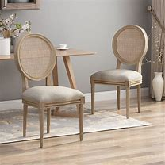

Q1) **Design principle for above picture**

**visibility**: visible and tangible.

**affordance**: sit, stand, move and can be used to keep objects.

**natural mapping**: sit, stand, move and can be used to keep objects.

**constraints**:minimum 3 legs and maximum 4 legs.

material used should be strong and not breakable.

material used can be of plastic, wood or metal.

joints have to be strong.

tilt should be atleast 90 degrees and above to provide back support.

soft and smooth surface to sit.

**conceptual model**:the Chair is of average quality and looks old.it don't have side support.

**Feedbacks**: side support or arm rest can be provided.

damaged at some locations.

The legs can be made stright to provide more strength.

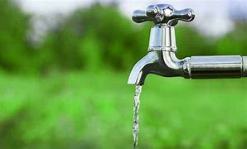

**Q2) Design principle for above picture**

**visibility**: visible and tangible.

**affordance**: on and off water flow.

**natural mapping**: on and off water flow.

**constraints**:on and off

only liqid should pass.

opening can be of normal size.

material used can be of plastic, metal to provide strength.

**conceptual model**: The Tap is of average quality.

**Feedbacks**:open and close symbols can be provided.

water purifier can be added to provide fresh water.

IOT can be added to automate the tap when hands are put under tap.

**Practical No: 5) WEB USER INTERFACE DESIGN-PAGES, NAVIGATION**

<!DOCTYPE html>

<html lang="en">

<head>

<meta charset="UTF-8">

<meta name="viewport" content="width=device-width, initial-scale=1.0">

<title>live cricket</title>

<style>

body {

font-family: Arial, sans-serif;

margin: 0;

padding: 0;

background-color: #f2f2f2;

}

header {

background-color: #333;

color: white;

text-align: center;

padding: 10px;

}

.container {

max-width: 1200px;

margin: 0 auto;

padding: 20px;

background: rebeccapurple;

}

.content {

padding: 20px;

border-radius: 5px;

box-shadow: 0 2px 5px rgba(0, 0, 0, 0.1);

}

.btn {

display: inline-block;

padding: 10px 20px;

margin: 10px,10px;

color: white;

text-align: center;

text-decoration: none;

border-radius: 5px;

transition: background-color 0.3s ease;

}

.btn:hover {

background-color: #0056b3;

}

footer {

text-align: center;

padding: 10px;

background-color: #333;

color: white;

}

</style>

</head>

<body>

<header >

<h1>Live cricket score</h1>

</header>

<div class="container">

<a href="score.html" class="btn">Live Matches</a><br>

<a href="completed_matches.html" class="btn">Completed Matches</a><br>

<a href="Points_table.html" class="btn">Points Table</a> <br>

<a href="https://www.cricbuzz.com/cricket-news" class="btn">Latest News</a>

</div>

</div>

<footer>

&copy; 2023 My Website. All rights reserved.

</body>

</html>



<!DOCTYPE html>

<html>

<head>

<style>

body {

background-color: aqua;

font-family: Arial, sans-serif;

}

.scoreboard {

width: 80%;

margin: 0 auto;

border-collapse: collapse;

text-align: center;

margin-top: 20px;

}

.scoreboard th, .scoreboard td {

border: 1px solid #ccc;

padding: 10px;

}

.scoreboard th {

background-color: #a4be46;

}

.team-name {

font-weight: bold;

}

.btn {

display: inline-block;

padding: 10px 20px;

background-color: #007bff;

color: white;

text-align: center;

text-decoration: none;

border-radius: 5px;

transition: background-color 0.3s ease;

}

.btn:hover {

background-color: #0056b3;

}

</style>

</head>

<body>

<h2 style="text-align: center;background-color: #007bff;padding: 20px;">completed matches</h2>

<table class="scoreboard">

<tr>

<th>Team</th>

<th>Score</th>

<th>Overs</th>

<th>Wickets</th>

</tr>

<tr>

<td class="team-name">CSK</td>

<td>180/5</td>

<td>20</td>

<td>5</td>

</tr>

<tr class="innings">

<td class="team-name">MI</td>

<td>67/10</td>

<td>10.5</td>

<td>10</td>

</tr>

</table>

<div>

<p style="text-align: center;">CSK won by 113 runs</p>

</div>

<table class="scoreboard">

<tr>

<th>Team</th>

<th>Score</th>

<th>Overs</th>

<th>Wickets</th>

</tr>

<tr>

<td class="team-name">RCB</td>

<td>120/9</td>

<td>20</td>

<td>9</td>

</tr>

<tr class="innings">

<td class="team-name">DC</td>

<td>121/8</td>

<td>12.4</td>

<td>8</td>

</tr>

</table>

<div>

<p style="text-align: center;">DC won by 2 Wickets</p>

</div>

<table class="scoreboard">

<tr>

<th>Team</th>

<th>Score</th>

<th>Overs</th>

<th>Wickets</th>

</tr>

<tr>

<td class="team-name">LSG</td>

<td>209/4</td>

<td>20</td>

<td>4</td>

</tr>

<tr class="innings">

<td class="team-name">CSK</td>

<td>212/7</td>

<td>19.5</td>

<td>7</td>

</tr>

</table>

<div>

<p style="text-align: center;">CSK won by 3 Wickets</p>

</div>

<table class="scoreboard">

<tr>

<th>Team</th>

<th>Score</th>

<th>Overs</th>

<th>Wickets</th>

</tr>

<tr>

<td class="team-name">RCB</td>

<td>247/2</td>

<td>20</td>

<td>2</td>

</tr>

<tr class="innings">

<td class="team-name">MI</td>

<td>194/5</td>

<td>17.4</td>

<td>5</td>

</tr>

</table>

<div>

<p style="text-align: center;">RCB won by 53 runs</p>

</div>

<table class="scoreboard">

<tr>

<th>Team</th>

<th>Score</th>

<th>Overs</th>

<th>Wickets</th>

</tr>

<tr>

<td class="team-name">CSK</td>

<td>220/5</td>

<td>20</td>

<td>5</td>

</tr>

<tr class="innings">

<td class="team-name">MI</td>

<td>180/8</td>

<td>20</td>

<td>8</td>

</tr>

</table>

<div>

<p style="text-align: center;">CSK won by 40 runs and qualified for the playoffs</p>

</div>

<div class="content" style="text-align: center;">

<a href="index.html" class="btn"> go back</a>

<a href="Points_table.html" class="btn">Points table</a>

</div>

</body>

</html>





<!DOCTYPE html>

<html>

<head>

<style>

table {

border-collapse: collapse;

width: 100%;

margin-bottom: 20px;

}

th, td {

border: 1px solid black;

padding: 8px;

text-align: center;

}

.btn {

display: inline-block;

padding: 10px 20px;

background-color: #007bff;

color: white;

text-align: center;

text-decoration: none;

border-radius: 5px;

transition: background-color 0.3s ease;

}

.btn:hover {

background-color: #0056b3;

}

.content {

padding: 20px;

border-radius: 5px;

box-shadow: 0 2px 5px rgba(0, 0, 0, 0.1);

}

</style>

</head>

<body style="background-image: url('bgi.jpg');;">

<h2>Points Table</h2>

<div>

<table>

<tr>

<th>Team</th>

<th>Played</th>

<th>Won</th>

<th>Drawn</th>

<th>Lost</th>

<th>Points</th>

</tr>

<tr>

<td>CSK(Q)</td>

<td>10</td>

<td>7</td>

<td>2</td>

<td>1</td>

<td>23</td>

</tr>

<tr>

<td>LSG</td>

<td>10</td>

<td>6</td>

<td>3</td>

<td>1</td>

<td>21</td>

</tr>

<tr>

<td>RCB</td>

<td>10</td>

<td>5</td>

<td>2</td>

<td>3</td>

<td>17</td>

</tr>

<tr>

<td>DC</td>

<td>10</td>

<td>3</td>

<td>4</td>

<td>3</td>

<td>13</td>

</tr>

<tr>

<td>MI</td>

<td>10</td>

<td>2</td>

<td>3</td>

<td>5</td>

<td>9</td>

</tr>

</table>

</div>

<div class="content" style="text-align: center;">

<a href="index.html" class="btn"> go back</a>

</div>

</body>

</html>



**Practical No: 6) PAPER PROTOTYPING USING TEMPLATES**

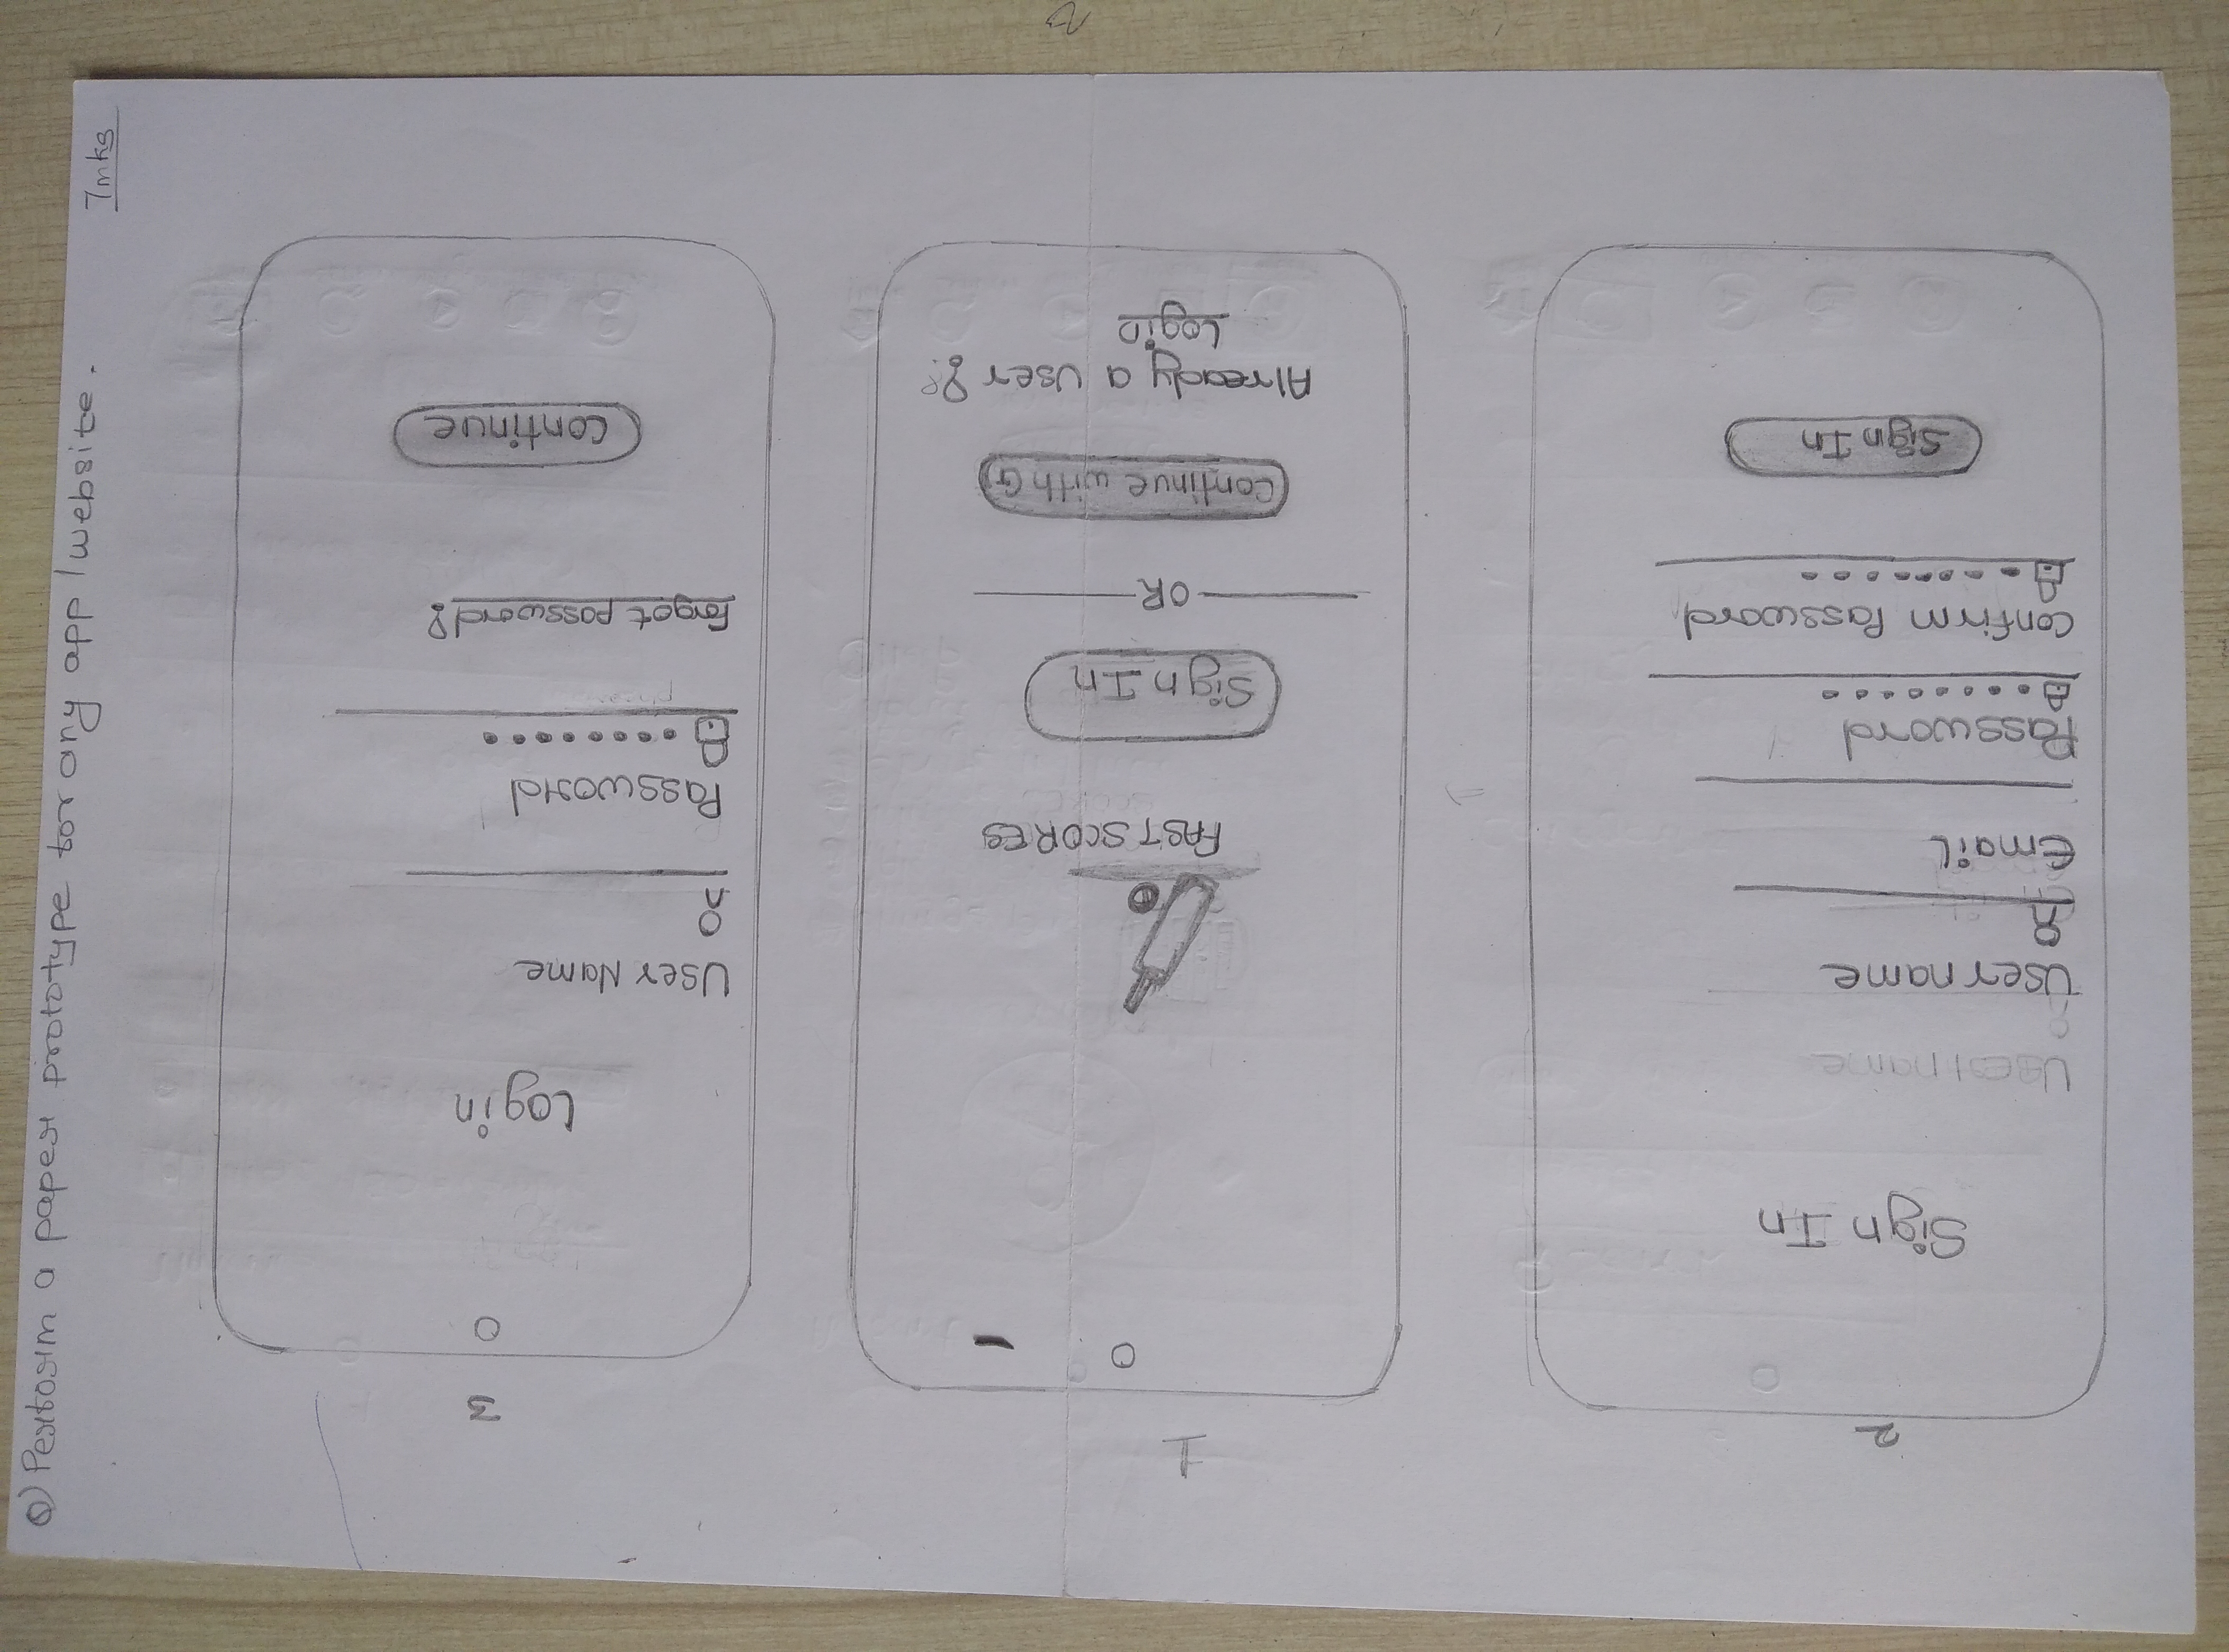

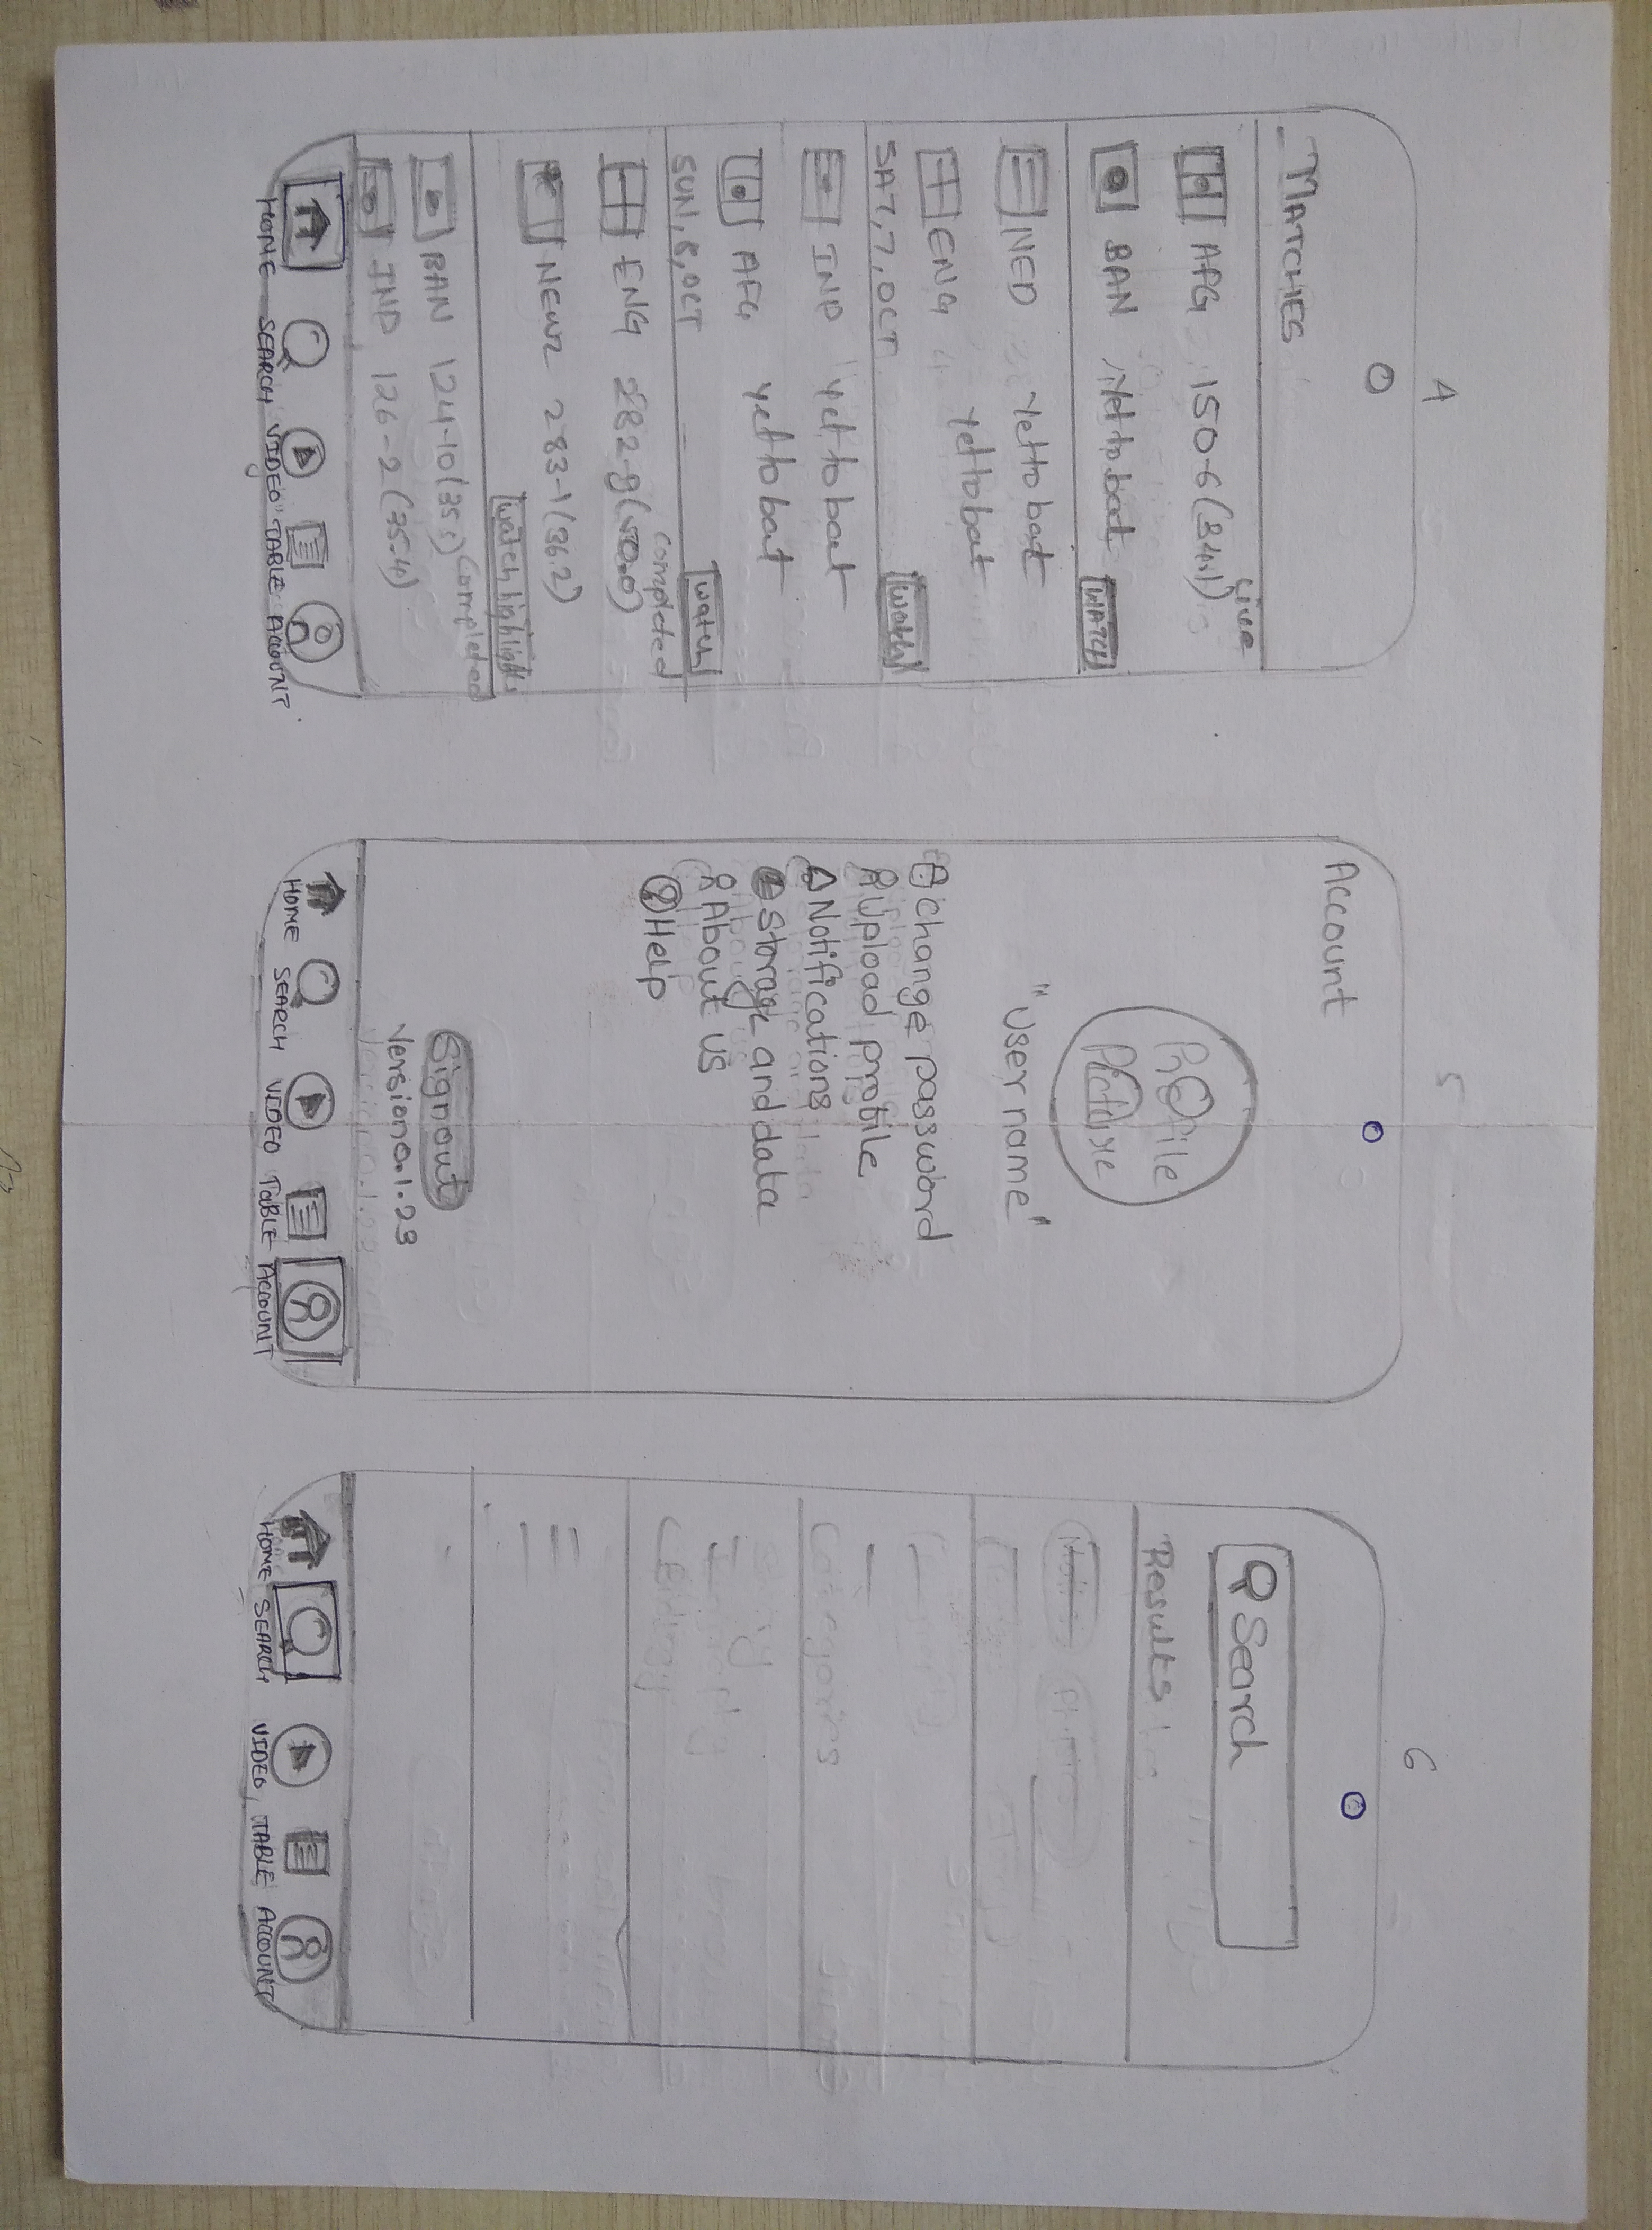

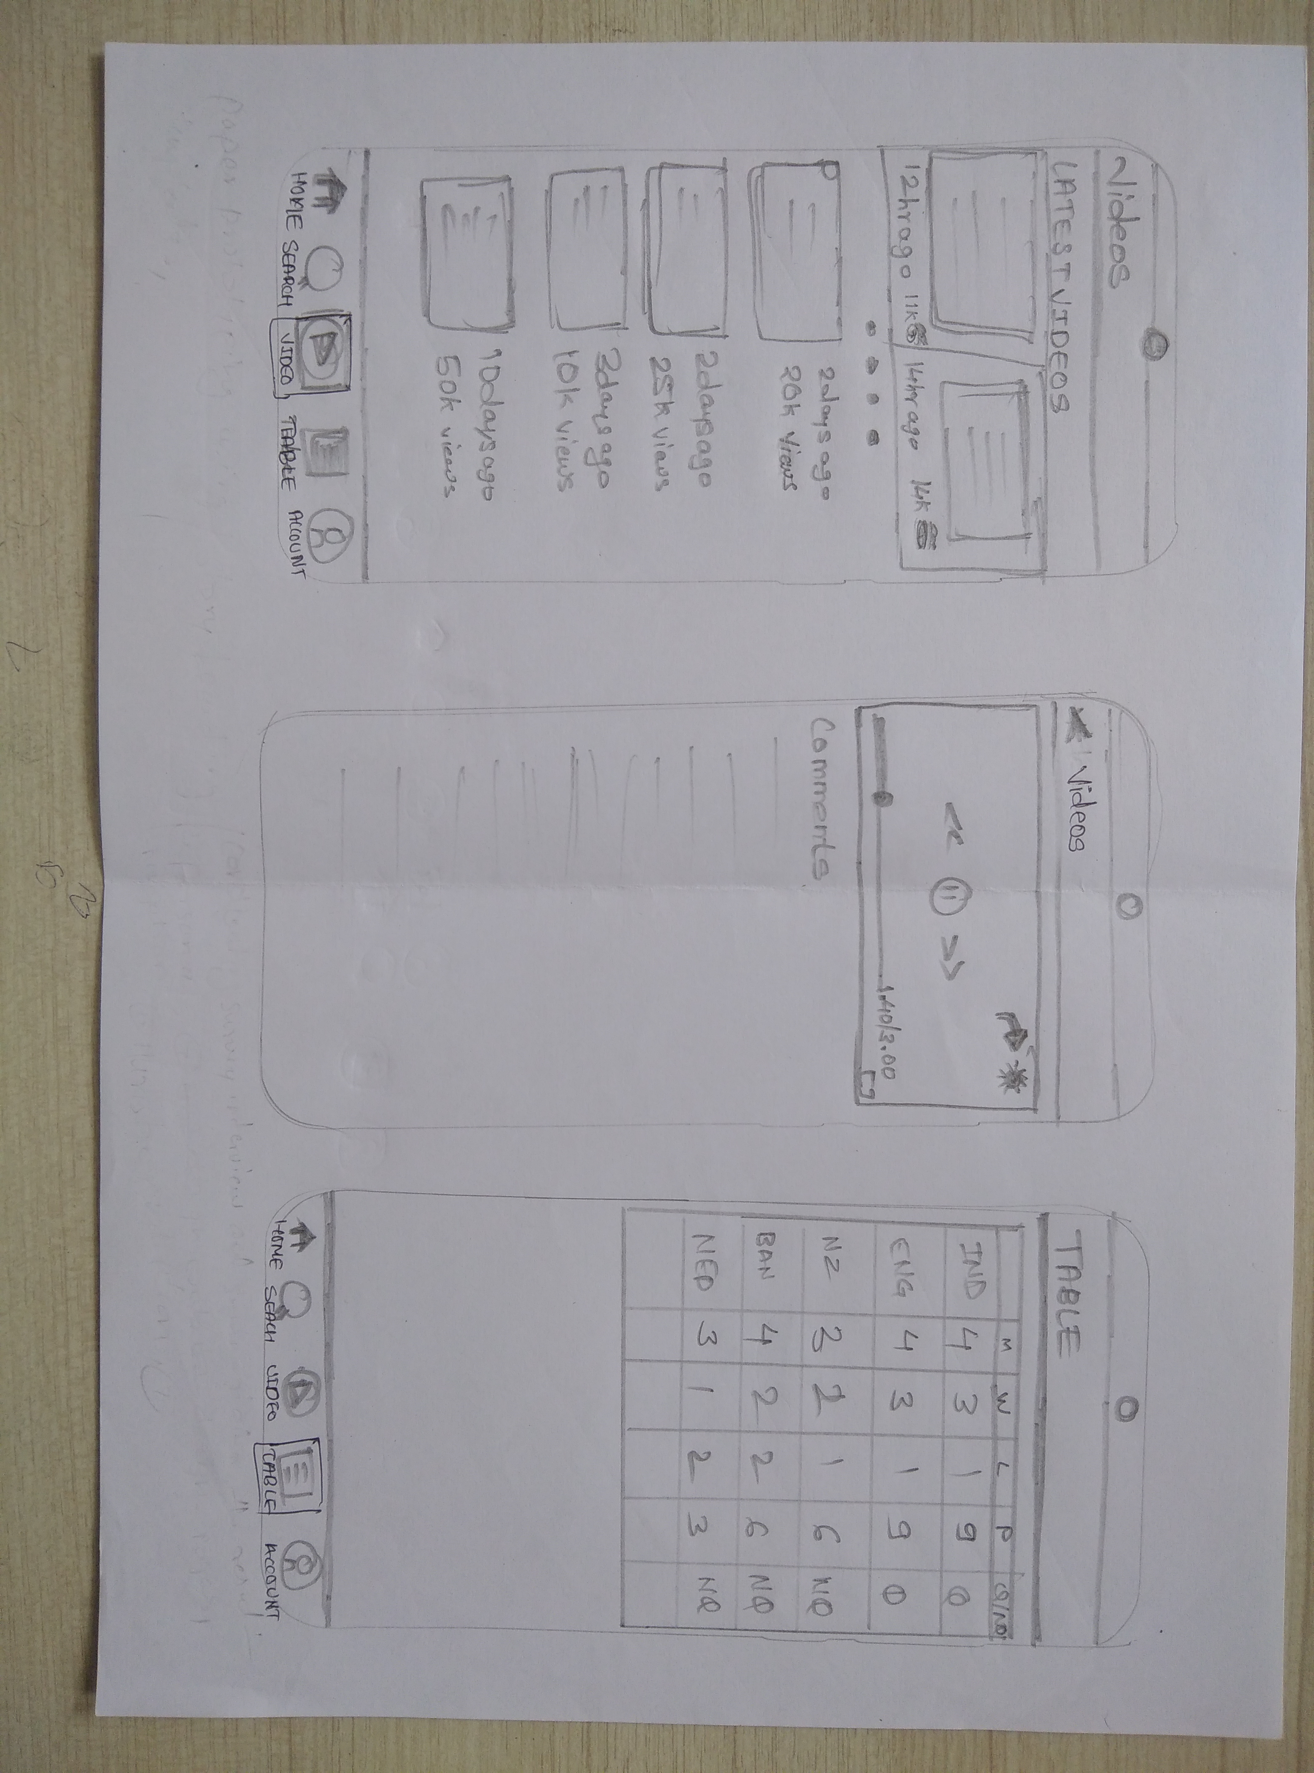

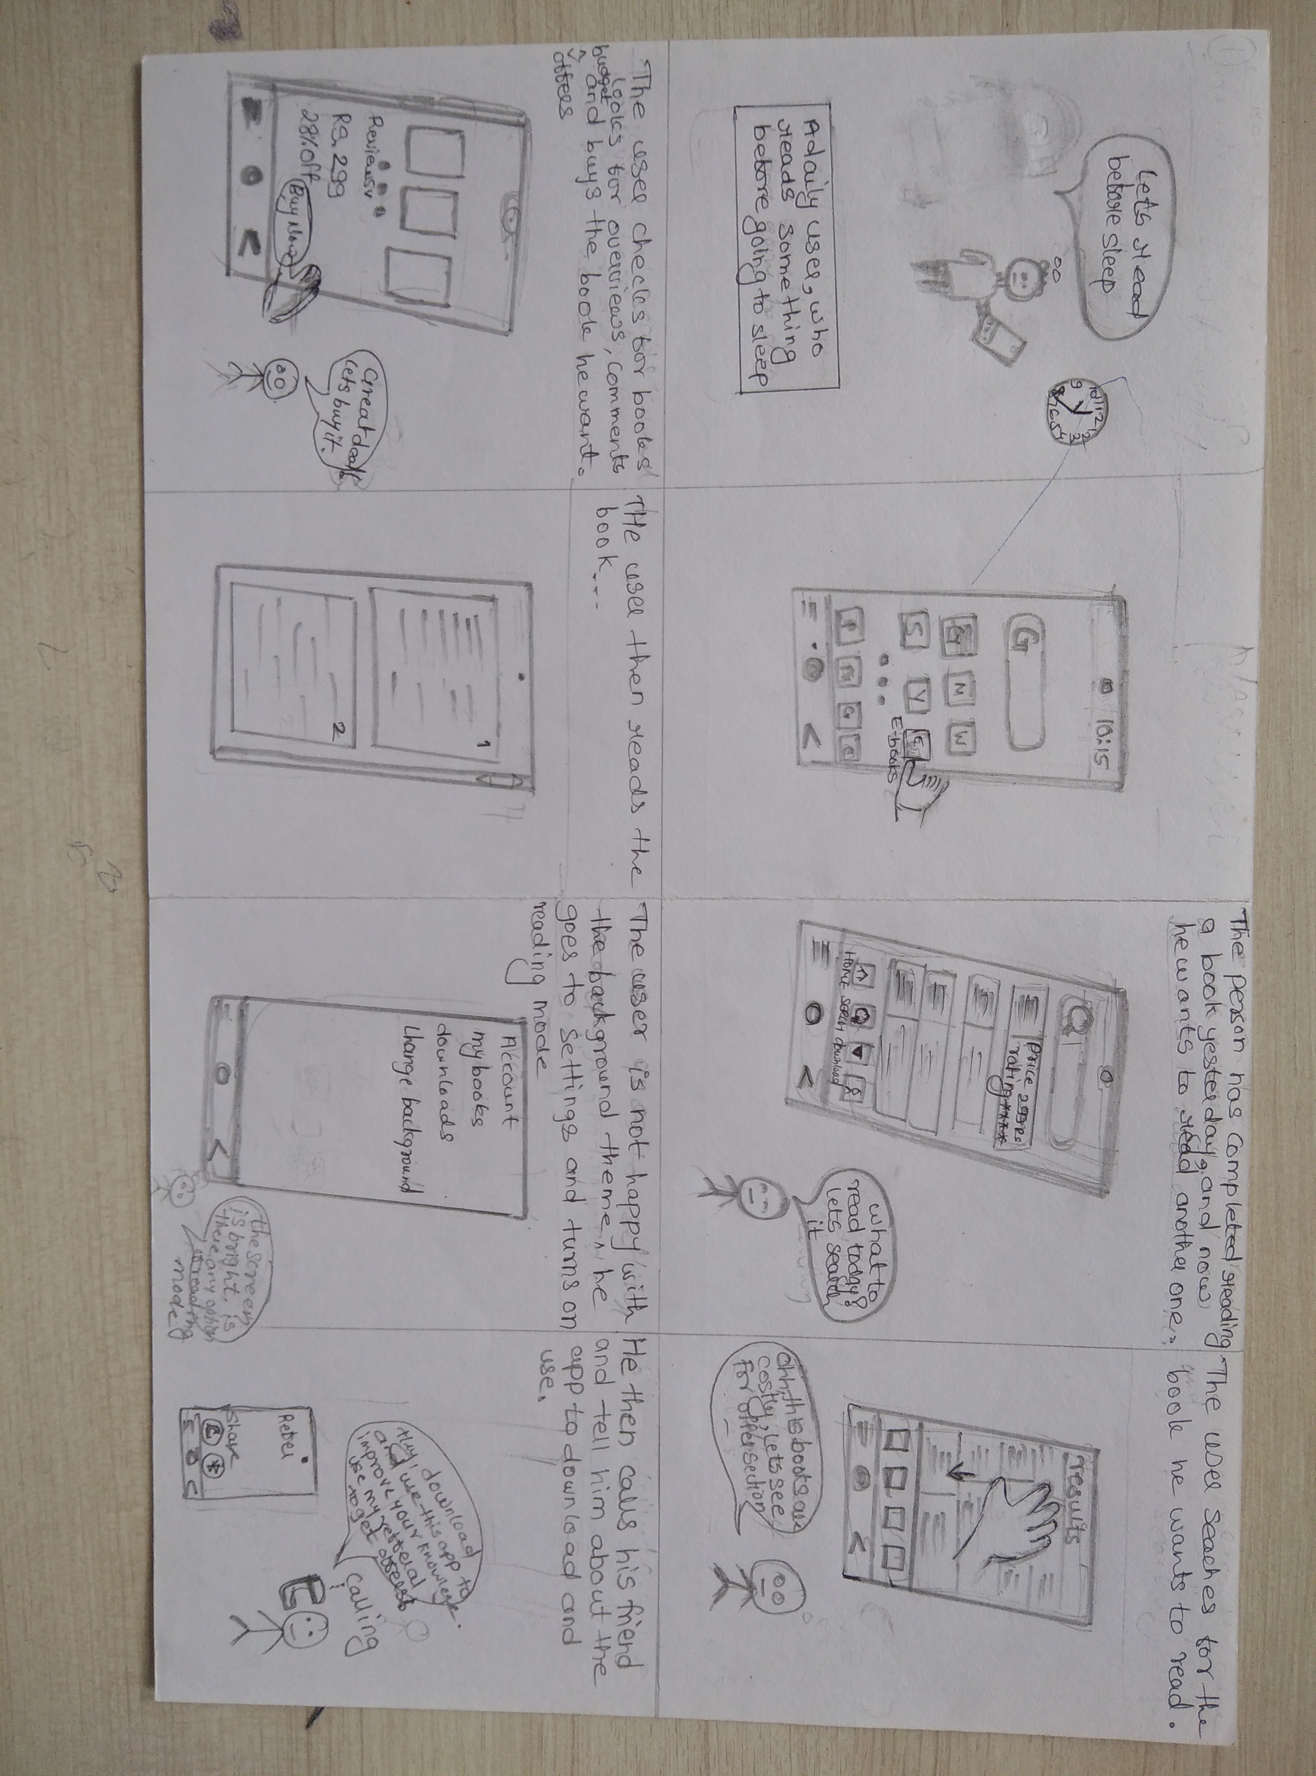**Practical No: 7) STORYBOARDING**

Rohan Gawas is a professional software engineer. He completed is software engineering from Goa College Engineering in 2017. He is working as senior software engineer in GOOGLE. As professional software engineer he like to learn new computer languages which are recently developed, in his free time he used Udemy website to learn in free time. Udemy is best platform to learn new languages in free time. From childhood Rohan was curious to know how computer works in real.

Rohan likes to read books, develop new games for kids and also like to improve their quality. Rohan by nature is a cool, friendly and like to help others in their works. While working on project Rohan always try to give his 100% effort on that.

Mayur Sharma is a highly accomplished mechanical engineer known for his innovative contributions to the field. Mayur displayed an early fascination with how things worked. His childhood was filled with dismantling and reassembling household appliances, sparking he interest in engineering. Mayur currently works in Vedanta. Besides as a mechanical engineer he likes to create design/interface for different websites and apps. He use Udemy platform to learn how to create user friendly design. He likes to learn through Udemy as they teach coding by scratch.

He travel and make travelling vlogs which he post on instagram. He also like to play cricket, chess and also like swimming. Mayur wants to become successful designer and also want show his skills to all through instagram. Currently 0.1Million people follow him on instagram.